**Authorizing ARM Template using Visual Studio 2019**

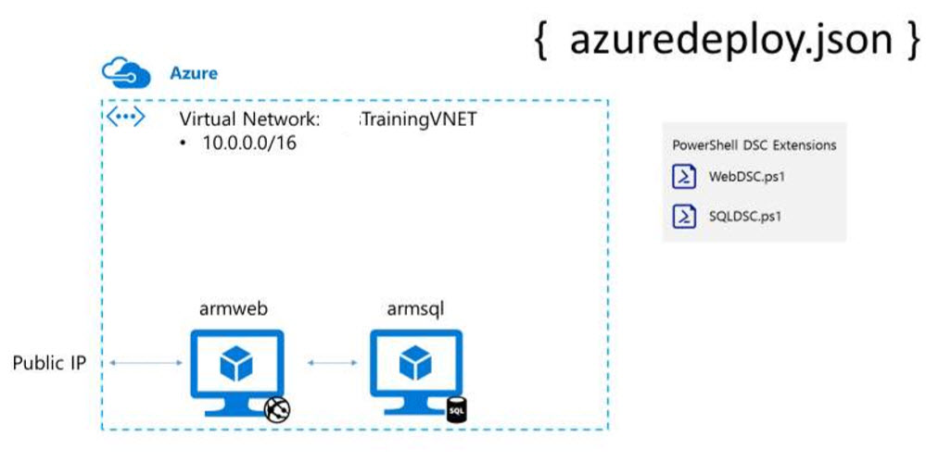

Step 1: Start Visual Studio 2019

Select Cloud -> Azure Resource Group template

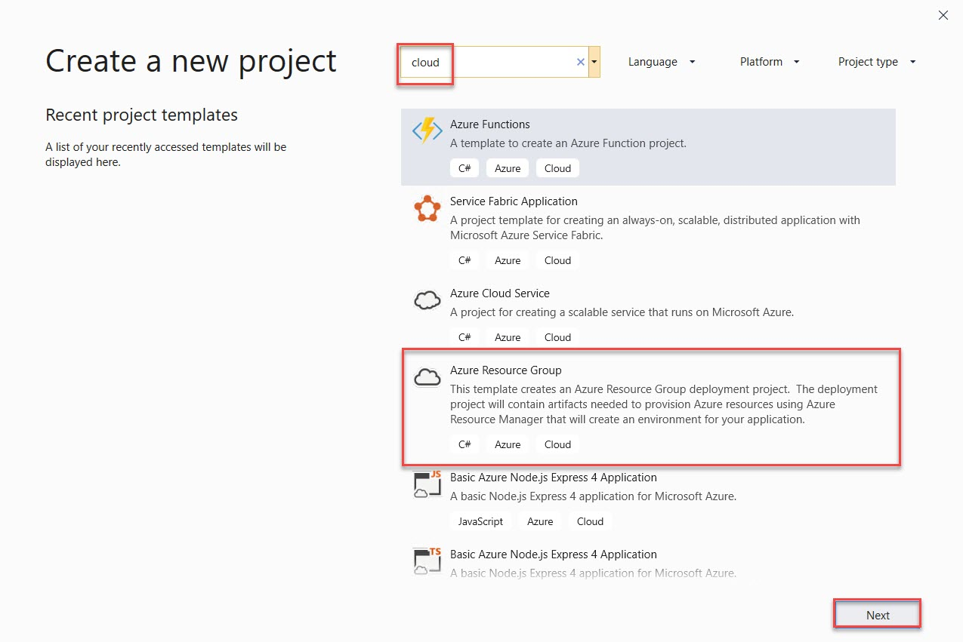

File -> New -> Project

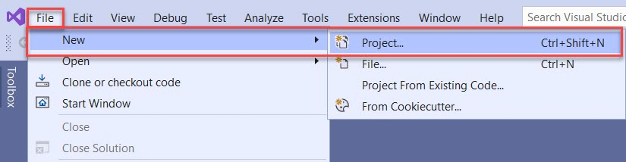

If you want to change Project name you can change and click on Create button.

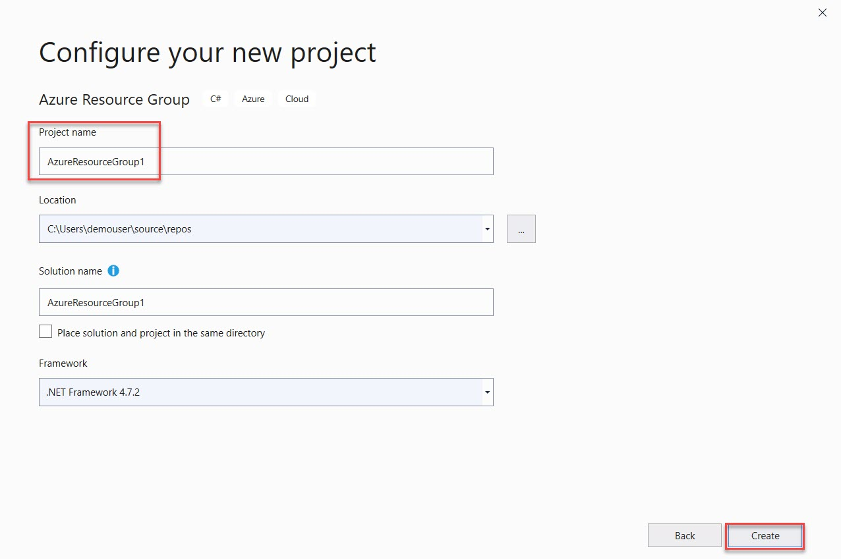

Step 3: Select Blank Template

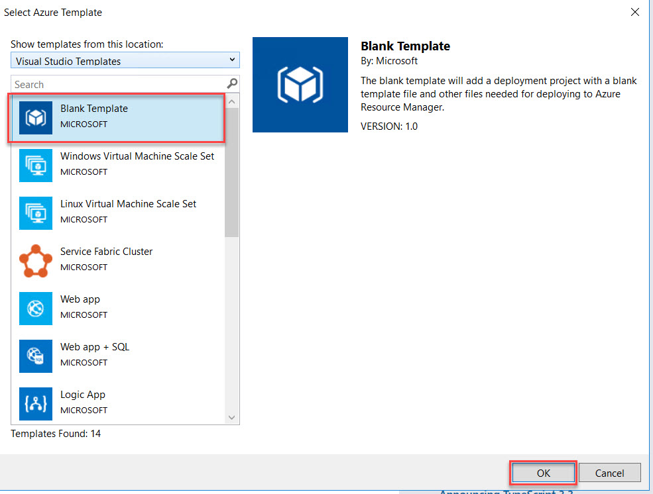

Step 4: Open **azuredeploy.json** file

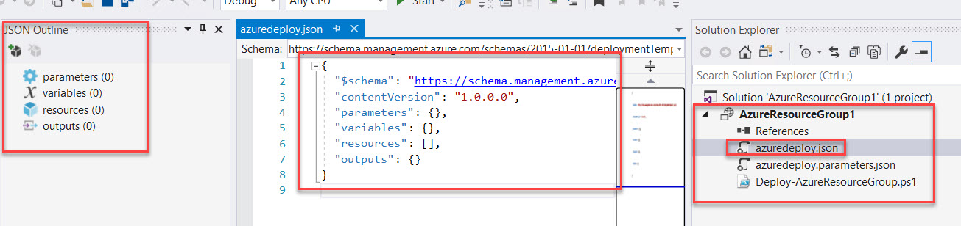

Step 5: Left side JSON Outline window will be there

Right click on resource -> Add New Resource

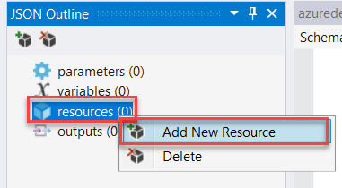

Step 6: Search for **Virtual Network**

Name: **TrainingVNET**

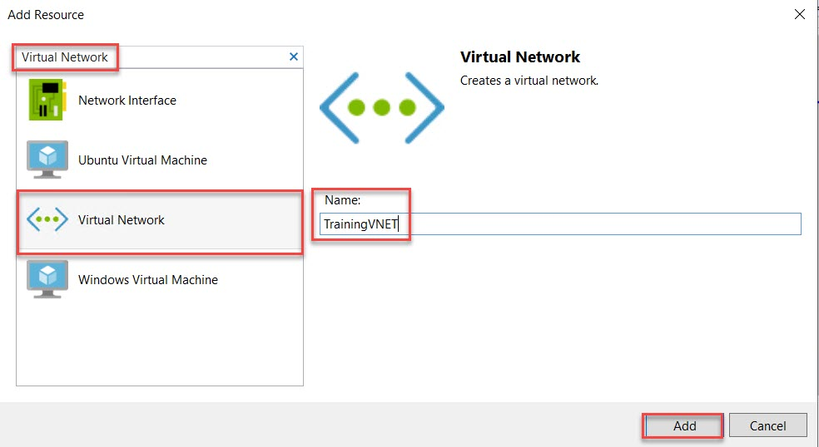

Step 7: Navigate to Virtual Network Variables Ex. VNet1, VNet2

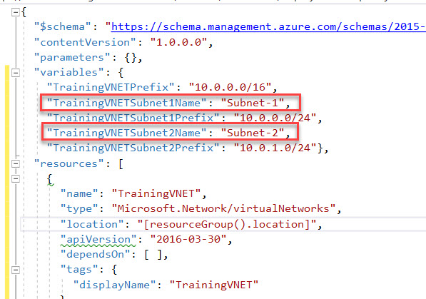

Rename with as below:

"TrainingVNETSubnet1Name": "FrontendNetwork"

"TrainingVNETSubnet2Name": "BackendNetwork"

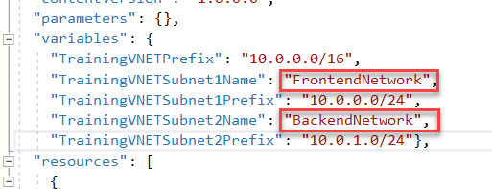

Step 8: Right Click on Project -> Deploy -> New…

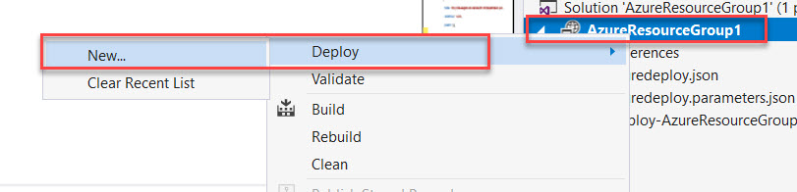

Enter you Microsoft Azure Credentials. Choose Subscription and Create New Resource Group

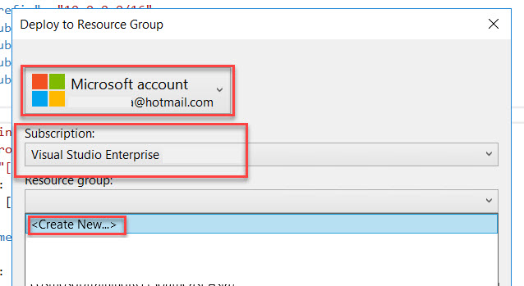

Enter Resource Group Name: **ARMLabRG**

Resource Group Location: Choose any nearest region and Create

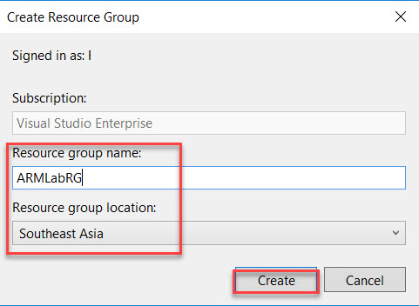

Step 9: Check other options and click on Deploy button.

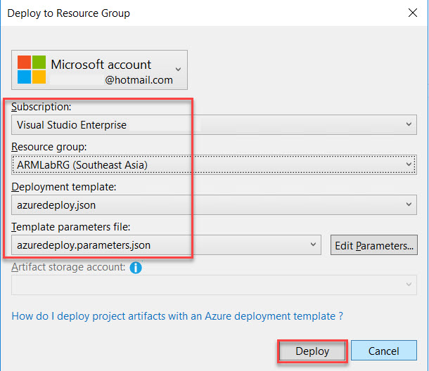

Wait for few minutes to deploy on Cloud

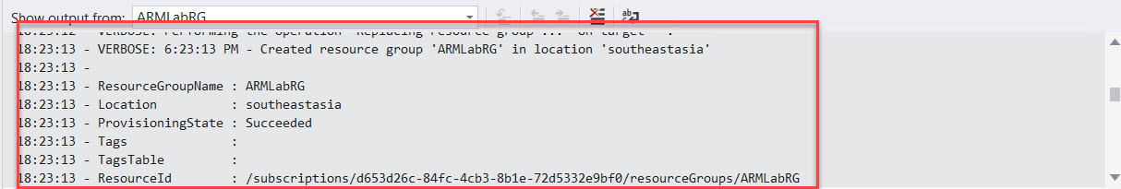

Step 10: Navigate to Azure Portal and check with Resource Group Name.

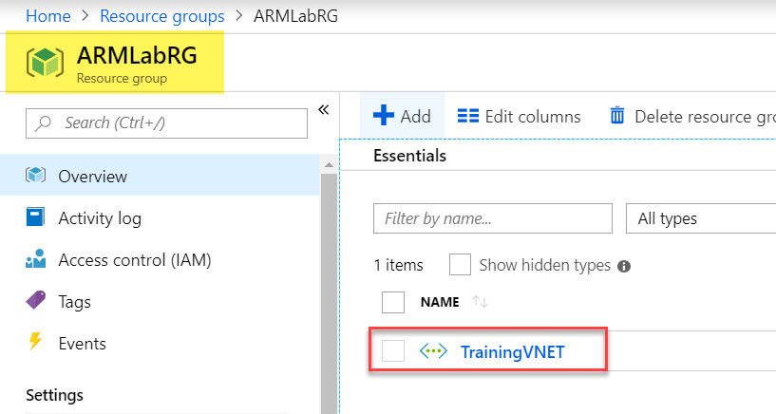

Step 11: Again, Right click on resource -> Add New Resource

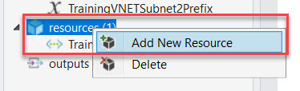

Step 12: Search for **Storage**

Name: Use any unique short name because at deployment time extra character will be added by Azure. Ex. **armstrg**

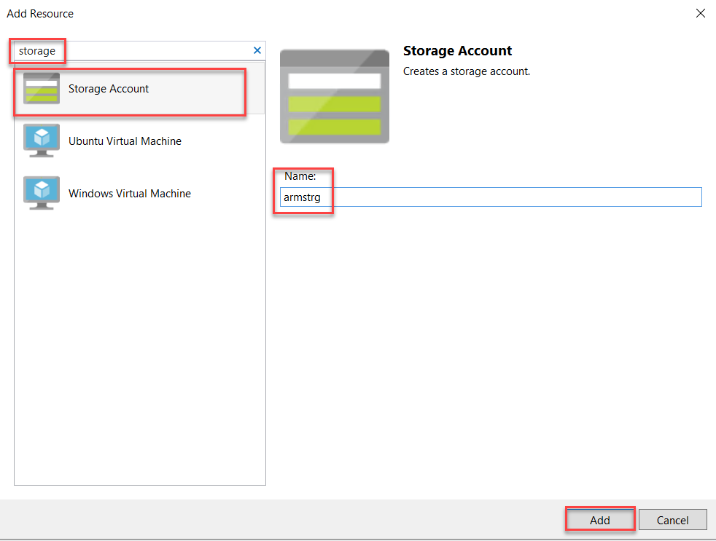

Step 13: Select Storage parameter and Remove **Standard_ZRS** because for Virtual Machine its not supported.

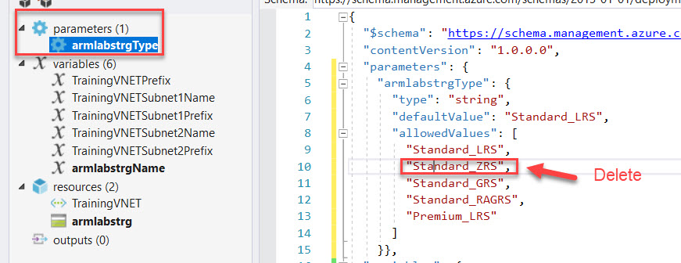

Also we are working with database so we get faster operations

Change **defaultValue** to “Premium_LRS”

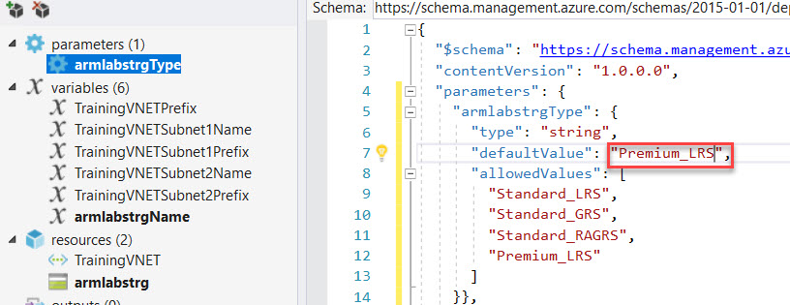

Step 14: Right Click on resources -> Add New Resource

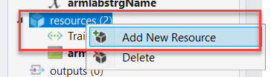

Step 15: Search for Windows Virtual Machine

Enter Name: **WebVM**

Storage Account: **Choose from list Ex. armstrg**

Virtual network/subnet: **[variables(‘TrainingVNETSubnet1Name’)] (TrainingVNET)**

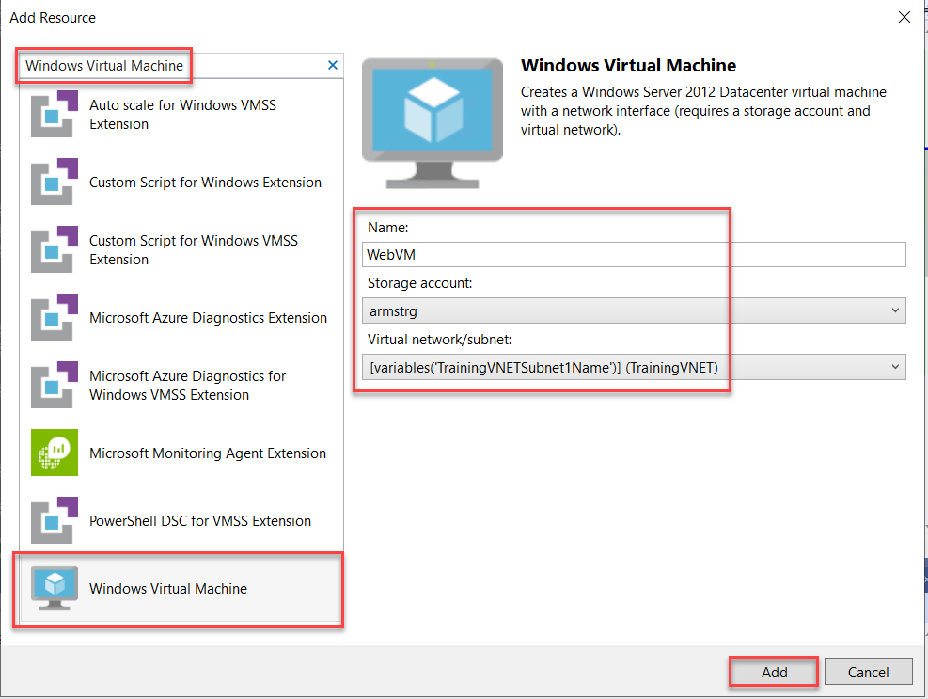

Step 16: Select **WebVMVmSize** variable and change size to **Standard_DS1_v2**

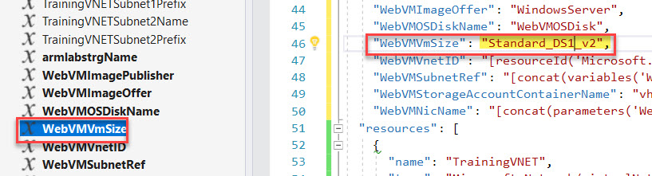

Step 17: Right Click on resource -> **Add New Resource**

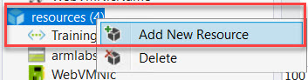

Search for **Public IP Address**

Name: **WebPublicIP**

Network interface: **WebVMNic**

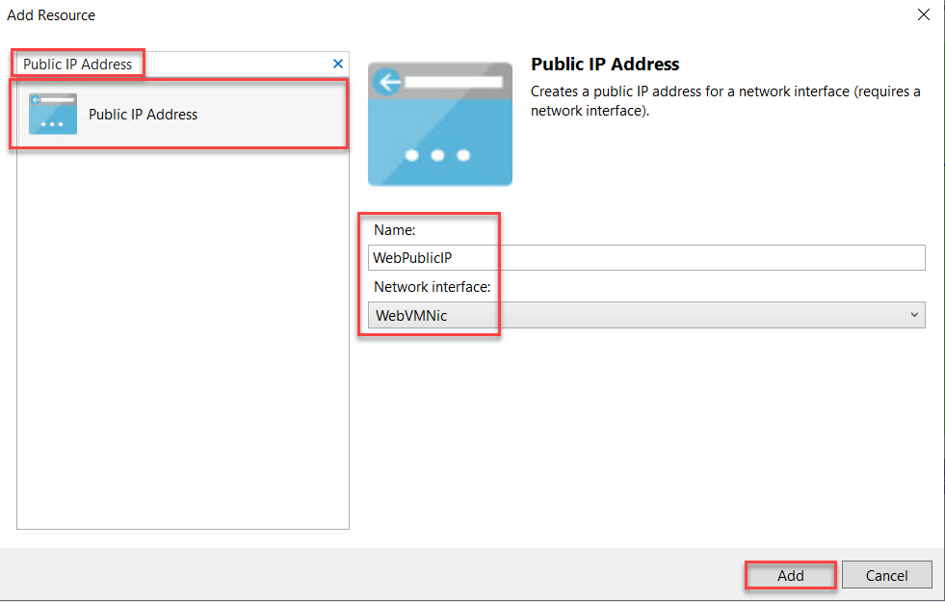

Step 18: Right on resources -> **Add New Resource**

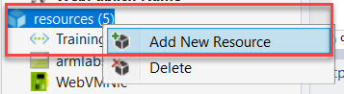

Search for **PowerShell DSC Extension**

Name: **WebDSC**

Virtual Machine: **WebVM**

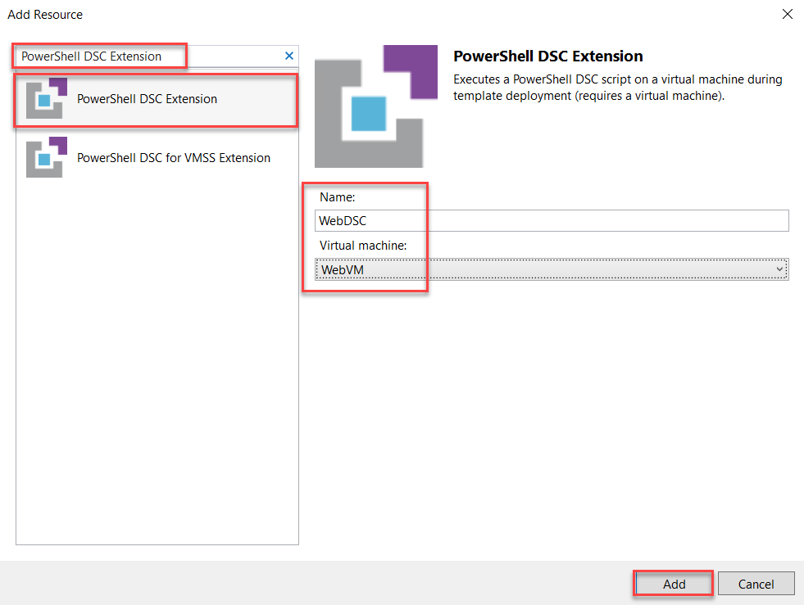

Step 19: Navigate to **Labs Folder** and Open **ARMWEB.ps1.txt** file

Remove **default code from WebDSC.ps1**

Copy complete code from **ARMWEB.ps1.txt** and paste into **WebDSC.ps1**

**Save** it.

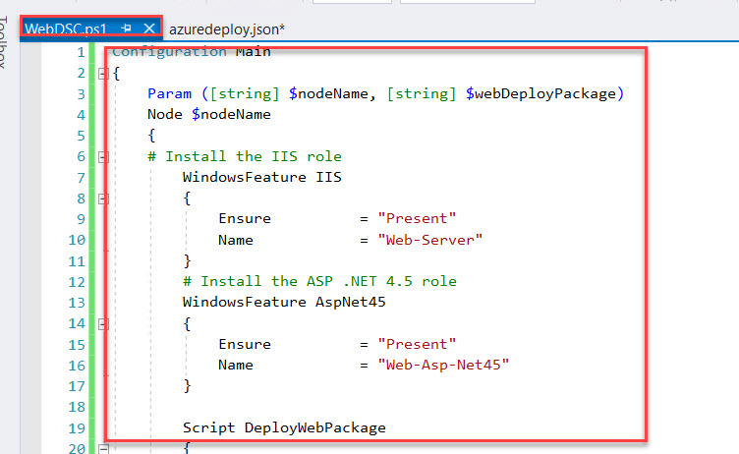

Step 20: Select _**artifactsLocationSasToken** parameter

Add **WebPackage**

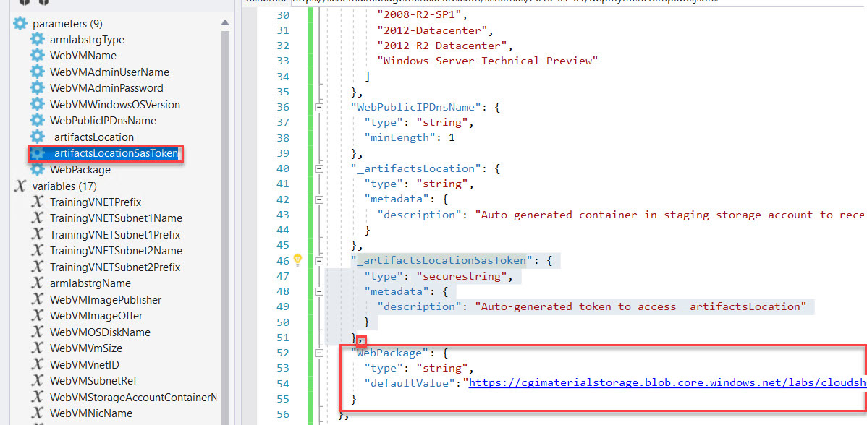

,

"WebPackage": {

"type": "string",

"defaultValue": "https://labfilesstorage.blob.core.windows.net/publicfiles/cloudshop.zip"

}

Step 21: Select **WebDSC** resource and search for

First add comma and add below line

"webDeployPackage": "[parameters('WebPackage')]"

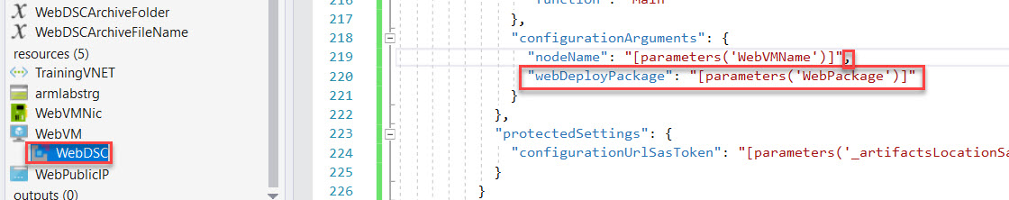

Step 22: Right click on resources -> Add New Resource

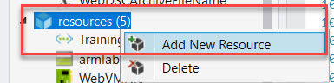

Step 23: Search for Windows Virtual Machine and enter below details

Name: SQLVM

Storage Account: armlabstrg

Virtual network/subnet: [variables(‘TrainingVNETSubnet2Name’)] (TrainingVNET)

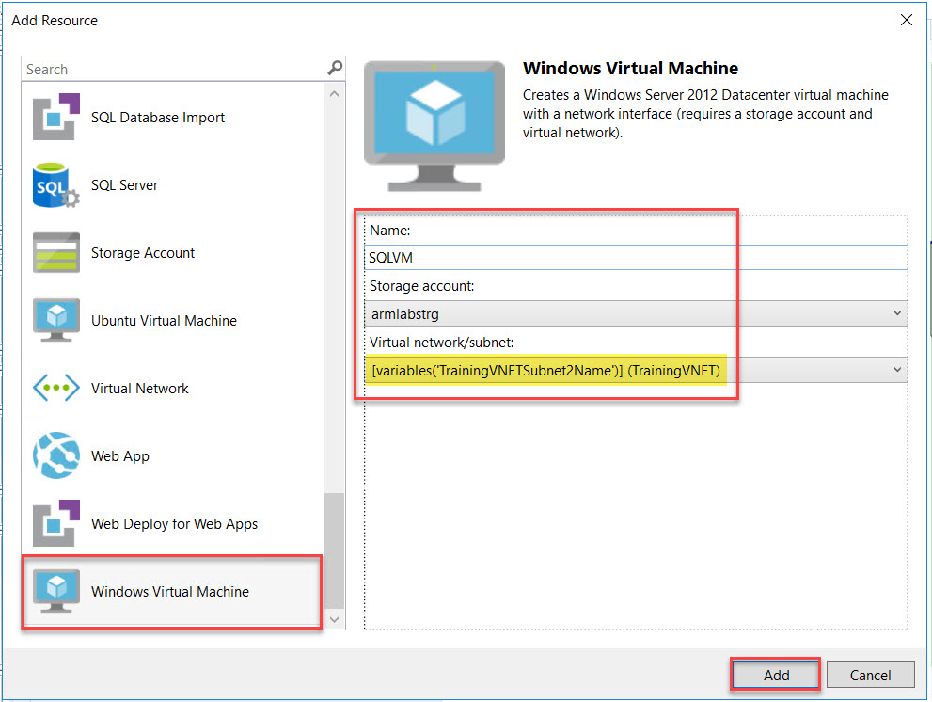

Step 24: Select **SQLVMVmSize** parameter

Change to Standard_DS1_v2

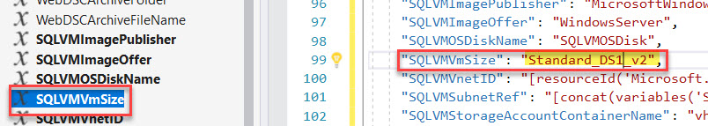

Step 25: Select **SQLVMImagePublisher** and **SQLVMImageOffer** variables.

"SQLVMImagePublisher": "MicrosoftSQLServer",

"SQLVMImageOffer": "SQL2014SP2-WS2012R2",

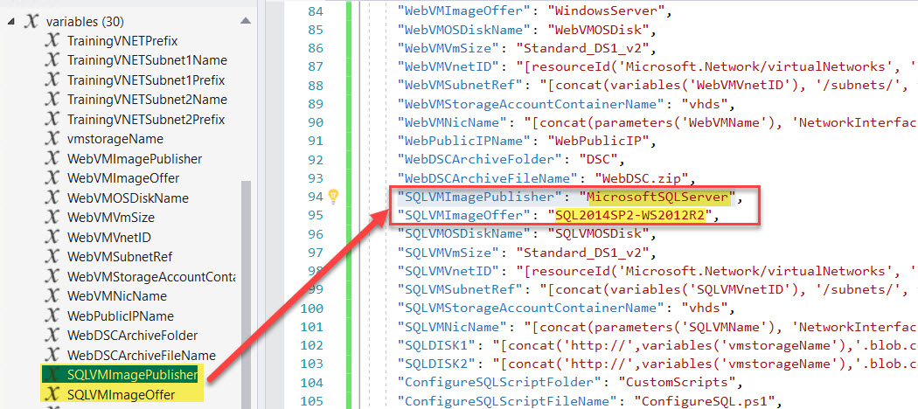

Step 26: Navigate to **SQLVMWindowsOSVersion** parameter and delete it.

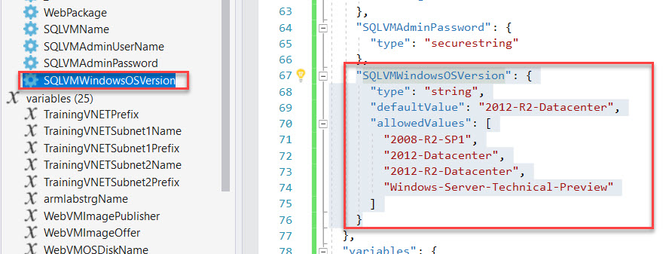

Add **SQLVMSKU** parameter

"SQLVMAdminUserName": {

"type": "string",

"minLength": 1

},

"SQLVMAdminPassword": {

"type": "securestring"

},

"SQLVMSKU": {

"type": "string",

"defaultValue": "Web",

"allowedValues": [

"Web",

"Standard"

]

}

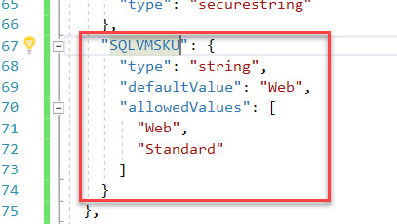

Step 27: After removing parameter error line will be there

Select **SQLVM** resource rename sku parameter **SQLVMWindowsOSVersion** to **SQLVMSKU**

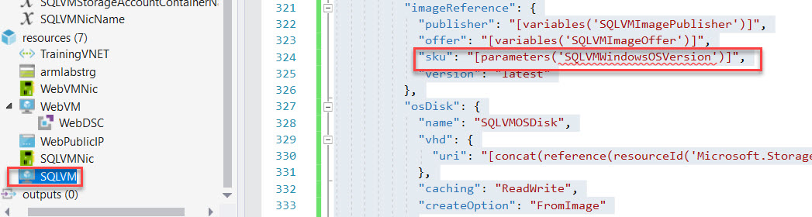

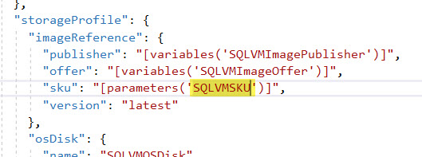

Step 28: Select **SQLVMNicName** and Add below code:

"SQLDISK1": "[concat('http://',variables('vmstorageName'),'.blob.core.windows.net/','vhds','/','dataDisk1.vhd')]",

"SQLDISK2": "[concat('http://',variables('vmstorageName'),'.blob.core.windows.net/','vhds','/','dataDisk2.vhd')]"

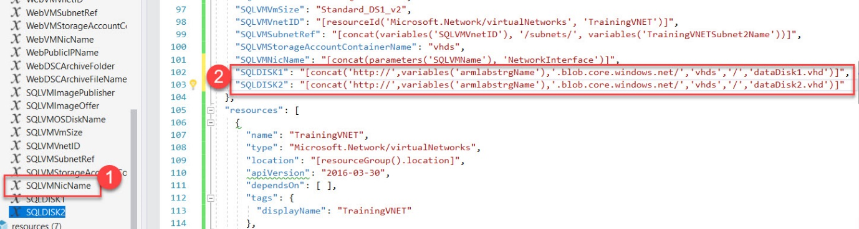

Step 29: Now add two extra data disk to SQLVM

Select **SQLVM** from resources

Add comma after osDisk

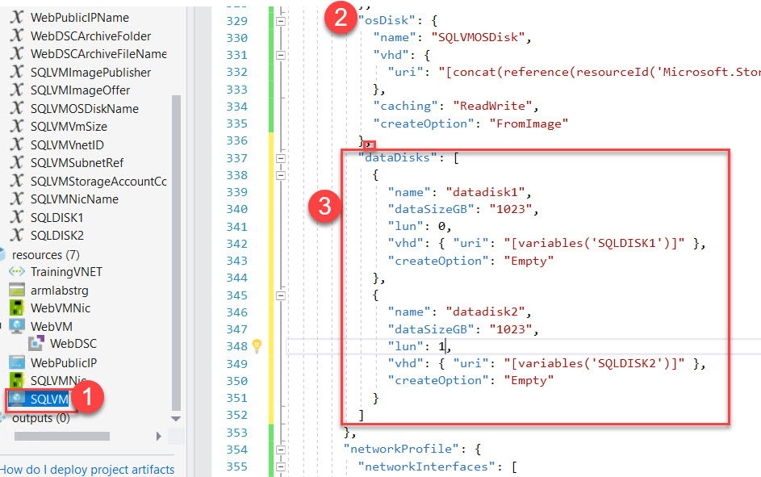

"dataDisks": [

{

"name": "datadisk1",

"diskSizeGB": "1023",

"lun": 0,

"vhd": { "uri": "[variables('SQLDISK1')]" },

"createOption": "Empty"

},

{

"name": "datadisk2",

"diskSizeGB": "1023",

"lun": 1,

"vhd": { "uri": "[variables('SQLDISK2')]" },

"createOption": "Empty"

}

]

Step 30: Add New Resource

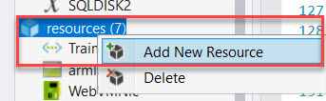

Search for **Custom Script for Windows Extension**

Name: **ConfigureSQL**

Virtual Machine: **SQLVM**

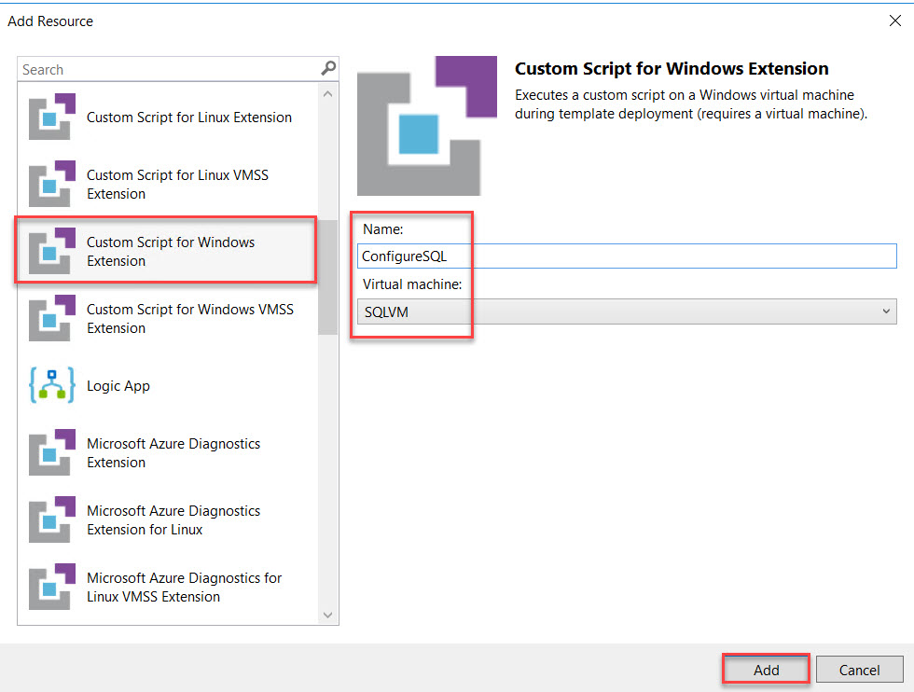

Step 31: Open **ConfigureSQL.ps1**

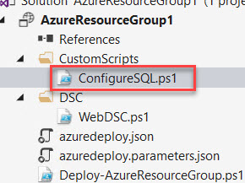

Remove all code.

Open **ARMSQL.ps1.txt**

**Copy and Paste into ConfigureSQL.ps1**

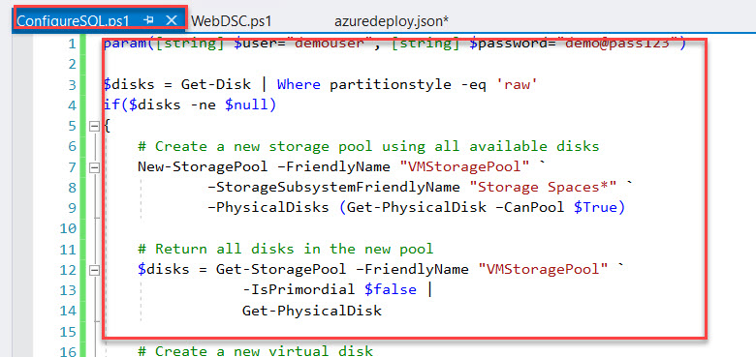

Step 32: This extension requires the local administrator credentials passed to it at deployment time. To accomplish that, switch back to the azuredeploy.json file and add a new variable at the end of the Variables section.

Add **Comma**

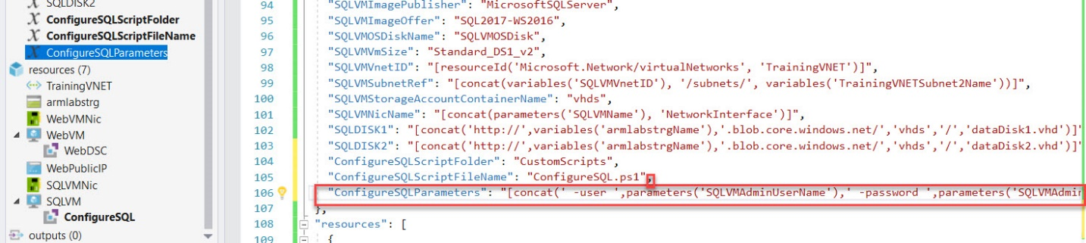

"ConfigureSQLParameters": "[concat(' -user ',parameters('SQLVMAdminUserName'),' -password ',parameters('SQLVMAdminPassword'))]"

Step 33: Select **ConfigureSQL** resource

**autoUpgradeMinorVersion** attribute will automatically use the latest minor version of the customScriptExtension. To avoid the risk of automatic updates breaking your script, set this property to false on the **ConfigureSQL** custom script extension.

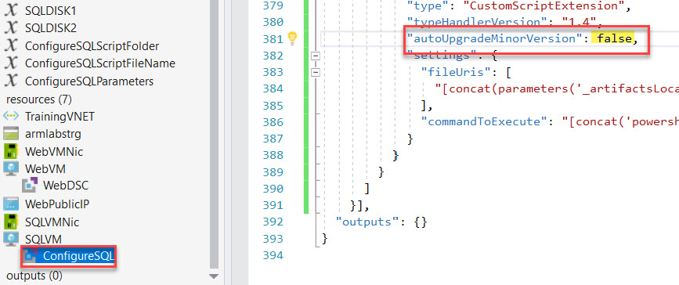

Step 34: Find the line that begins with "**commandToExecute**", and replace the entire line with the following

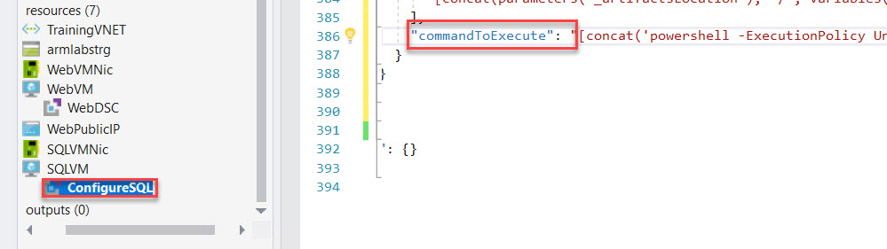



"commandToExecute": "[concat('powershell -ExecutionPolicy Unrestricted -File ', variables('ConfigureSQLScriptFolder'), '/', variables('ConfigureSQLScriptFileName'), ' ', variables('ConfigureSQLParameters'))]"

Step 35: Right Click on Project Name -> Deploy -> ARMLabRG

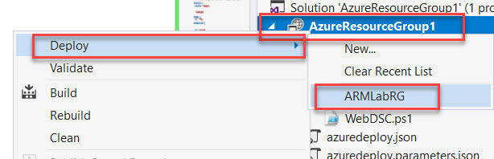

Step 36: Click on **Edit Paramteres….**

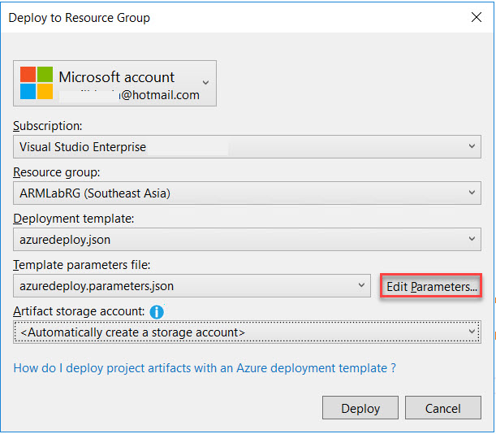

WebVMName: **armweb**

WebVMAdminUserName: **demouser**

WebVMAdminPassword: **demo@pass123**

WebPublicIPDnsName: **armpip (enter unique name Ex. armpip123)**

SQLVMNAme: **armsql**

SQLVMAdminUserName: **demouser**

SQLVMADAminPassword: **demo@pass123**

Check mark save passwords as plain text in the parameters file and Save button.

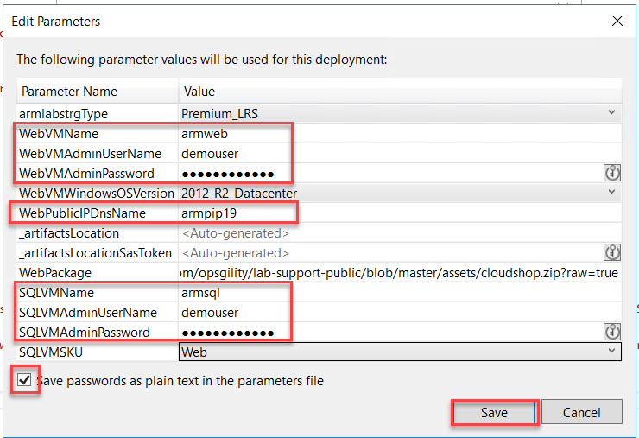

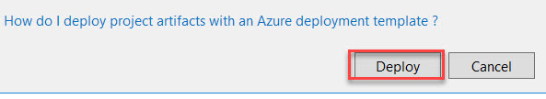

Step 37: Navigate to Azure Portal and Copy-Paste DNS Name in Browser

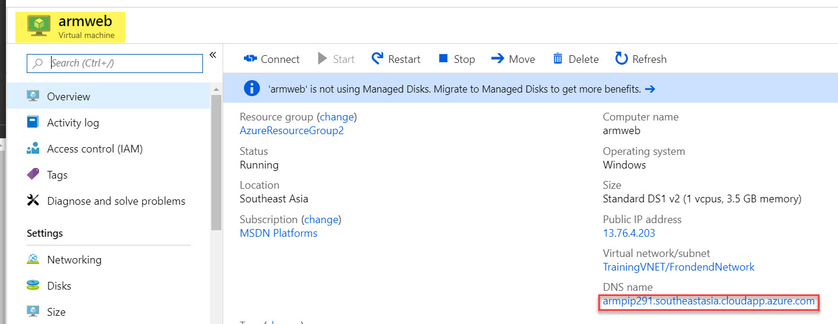

Website with Database will load

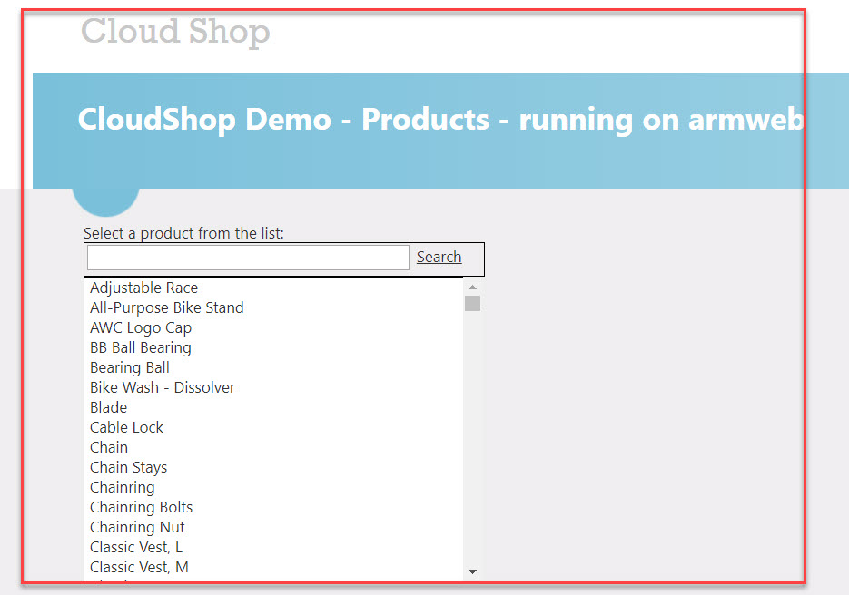

Note: **Website** accessing from **WebVM** and **Database** accessing **SQLVM**.

RDP can perform by **Private IP Address** of SQLVM via WebVM